Paper title

Author

Abstracts

Keywords

1. Introduction

What is a chatbot? And short history

Chatbots are pre-trained with knowledge (Bhattacharjya et al., 2022) and showcased as programs which create human AI interaction (Adamopoulou & Moussiades, 2020a) either for satisfaction of user or simulation of offline agents. (Lowry, Romano, Jenkins, & Guthrie, 2009). Alan Turing Can Machine Think, gave rise to ELIZA, First Chatbot in 1966. ELIZA, Psychotherapist’s simulator (Adamopoulou & Moussiades, 2020a)selected output template based upon a pattern of linguistic rules provided manually. (Bhattacharjya et al., 2022) PARRY (1973) also used in experiment (1979) gave domain for further research on high-speed response and learning (Adamopoulou & Moussiades, 2020b). Similar chatbot, but AI was introduced in Jabberwacky (Jabberwacky, 2019) used CleverScript. Predictable and slow response, conversation loop was still prior problems in chatbots with no scalability. (Jwala, 2019). ALICE (1995) was working better than ELIZA by using AIML. (Bhattacharjya et al., 2022).2001, chatbots like SmarterChild started to displaying movie times, sport score. (Molnar & Zoltan, 2018) After this, Machine learning and deep learning was well prior (Bhattacharjya et al., 2022) for research which resulted Siri, Watson, Google Assistance, Cortana, and Alexa. Watson won Jeopardy winners, Even EQ and IQ was taken into consideration in terms of Microsoft Xiaolace (Zhou, Gao, Li, & Shum, 2019), Google Assistance started predicting user needs, but data privacy and malwares were key cons of this intelligent chatbots. (Cortana Security flaw means your PC may be comprised, 2018) (Adamopoulou & Moussiades, 2020b).

What are the significances of chatbot?

Nearly all businesses are in the field of research of chatbots to create a friendly toy tool chatbot for customers. (Adamopoulou & Moussiades, 2020a)Mainly they are focusing on emotional (Xu, Liu, Guo, Sinha, & Akkiraju) requests and neutral responses. (Costa, 2018)

What are types of chatbot?

Chatbots are seen as task oriented or conversational. (Adamopoulou & Moussiades, 2020b) Automated service are provided like specific transactions using ML for task-oriented whereas personalized, knowledgeable, and interactive conversational response are generated using predictive intelligence and machine learning for conversational chatbots. (Bhattacharjya et al., 2022)

What is ChatGPT? Discuss along with its history and differences with normal chatbots.

(Blanchard et al., 2023) ChatGPT can generate natural-sounding text based on a large corpus of text, which has been pre-trained using unsupervised learning techniques and fine-tuned using supervised learning techniques.

(Eke, 2023) ChatGPT is a large language model that uses deep learning to generate human-like texts in response to prompts, and it has unique use cases such as generating responses in dialogues/conversations, explaining complex subjects or themes, and generating new codes. ChatGPT has a range of use cases, including generating responses in dialogues/conversation, explanation of complex subjects, generation of new codes or fixing of existing codes for errors. It has been hailed as "scary good" by proponents and still has the potential for further fine-tuning.

(Alberts et al., 2023) ChatGPT uses transformer-based models that process large amounts of data simultaneously, allowing for a revolution in the model's ability to understand and generate text.

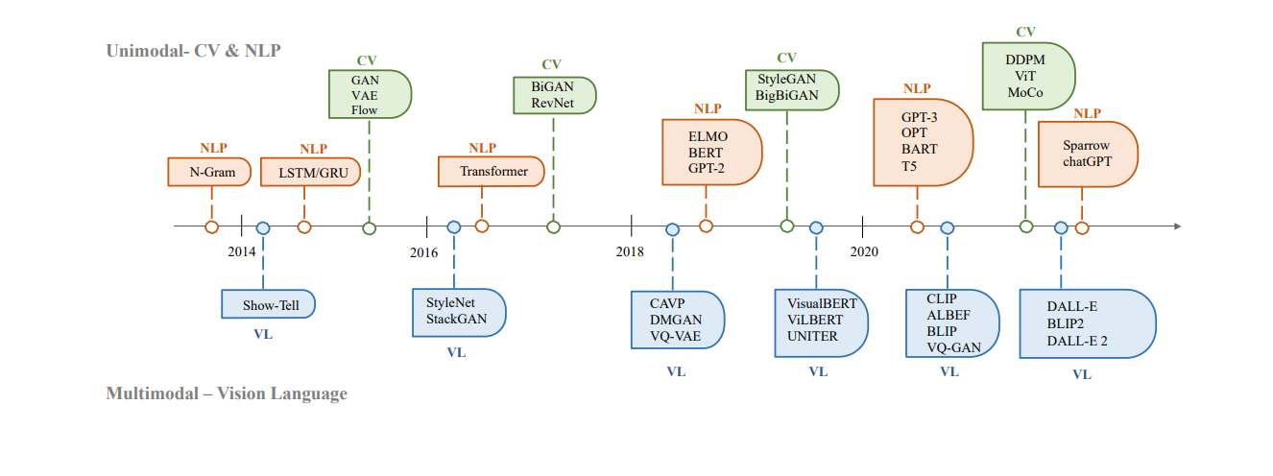

How chatGPT works? Explain with diagram.

2. Literature reivew

1. Analysis
2. Conclusion

Present your final verdicts / recommendations based on your study